Student Name: Liu Jiahao

Student ID: 21096764D

Lab1a Report:

1. Exercise

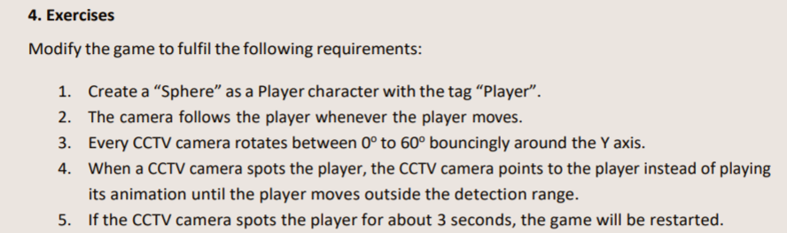

1. Ex1

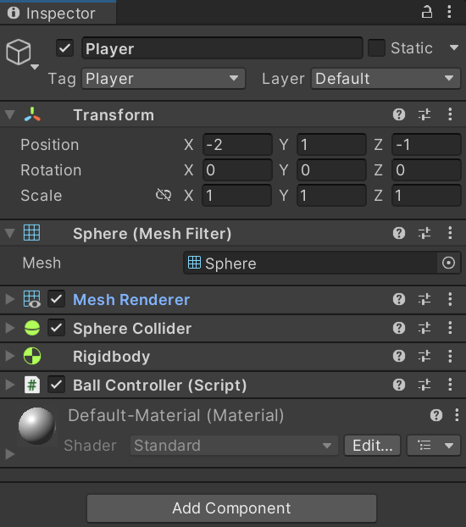

1. Exe2

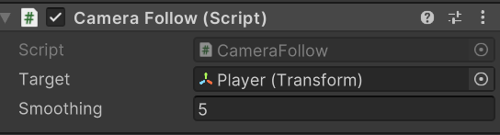

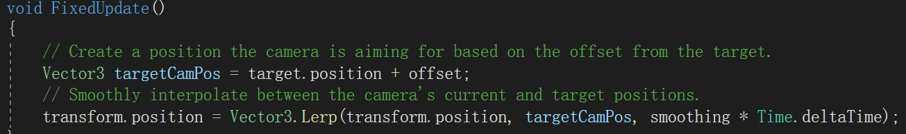

1. Ex3~5

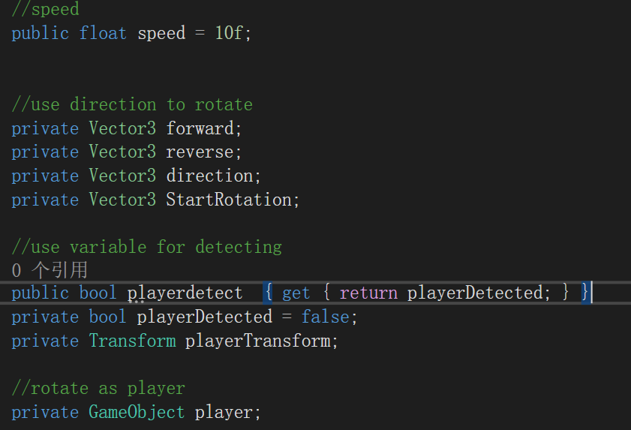

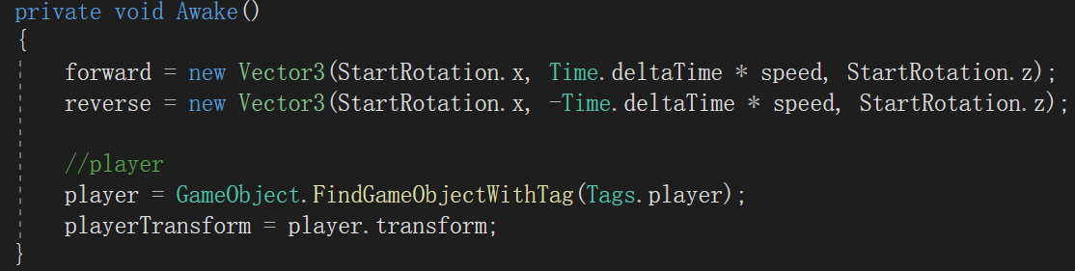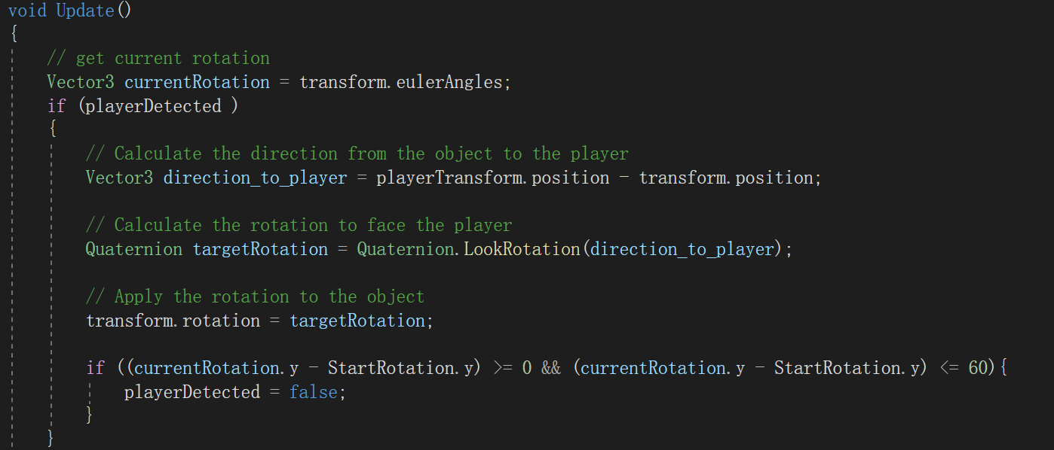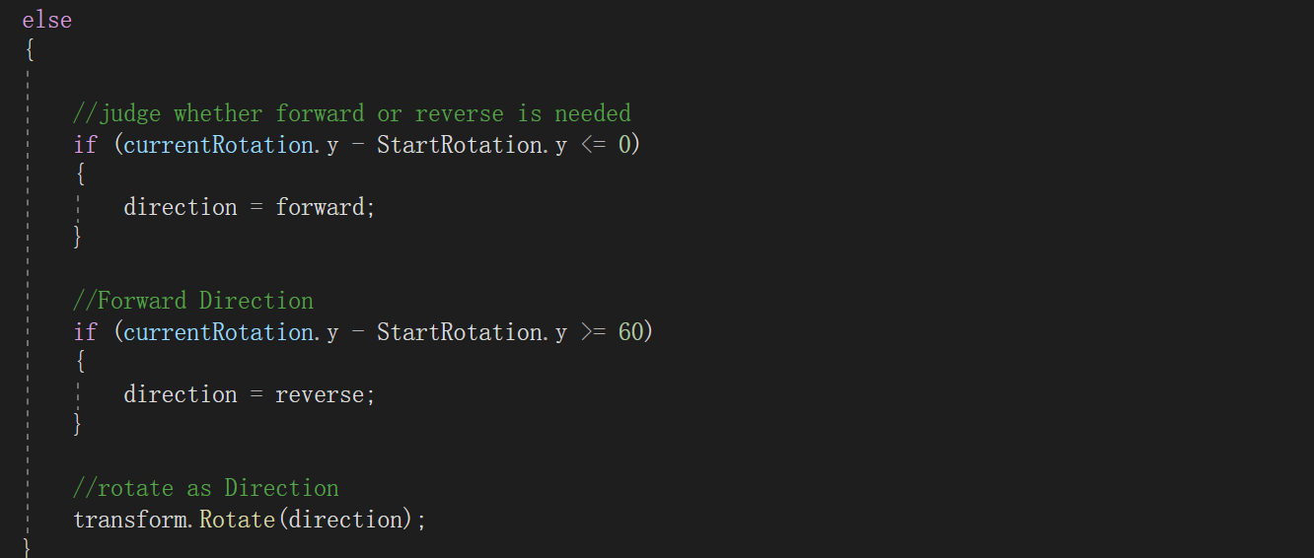

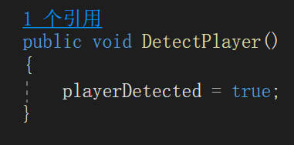

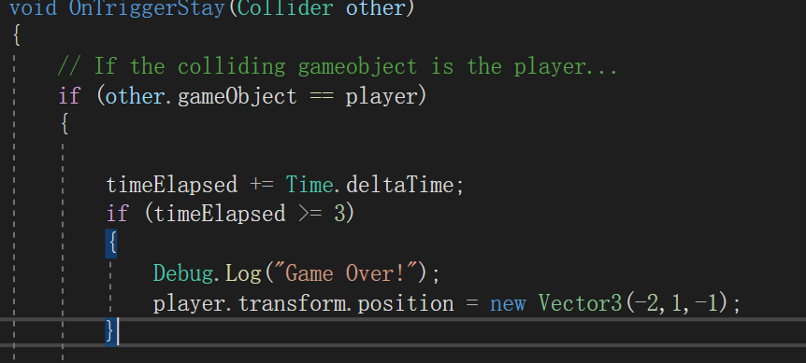

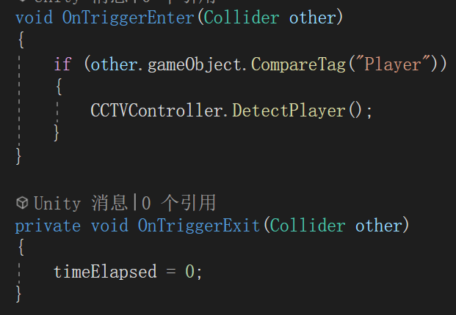

1. Problem met:

The problem happened when I first run the program and the collision between camera sight and player is not appeared. I was confused.

The first addressing way is to use animation to solve it. However, when using animation, the collision still not be detected.

After checking the code and the setting in unity, I found that the player setting and mesh renderer of CCTV camera collision is wrong, so I add the “mesh_frustum_collision” to mesh renderer of CCTV and change player setting.

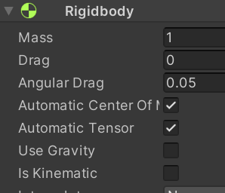

Also, the coding that make CCTV rotation is quite hard for me so I think a lot in this period. I finally reach the objective by storing initial rotation and updating current rotation and further detect the difference between them.

This lab not only enables me to better coding the script in Unity, but also get familiar with unity operation.